Here is the concept of the 13 May event, to be completed of course with other logos and partners or else. François-Marie Périer
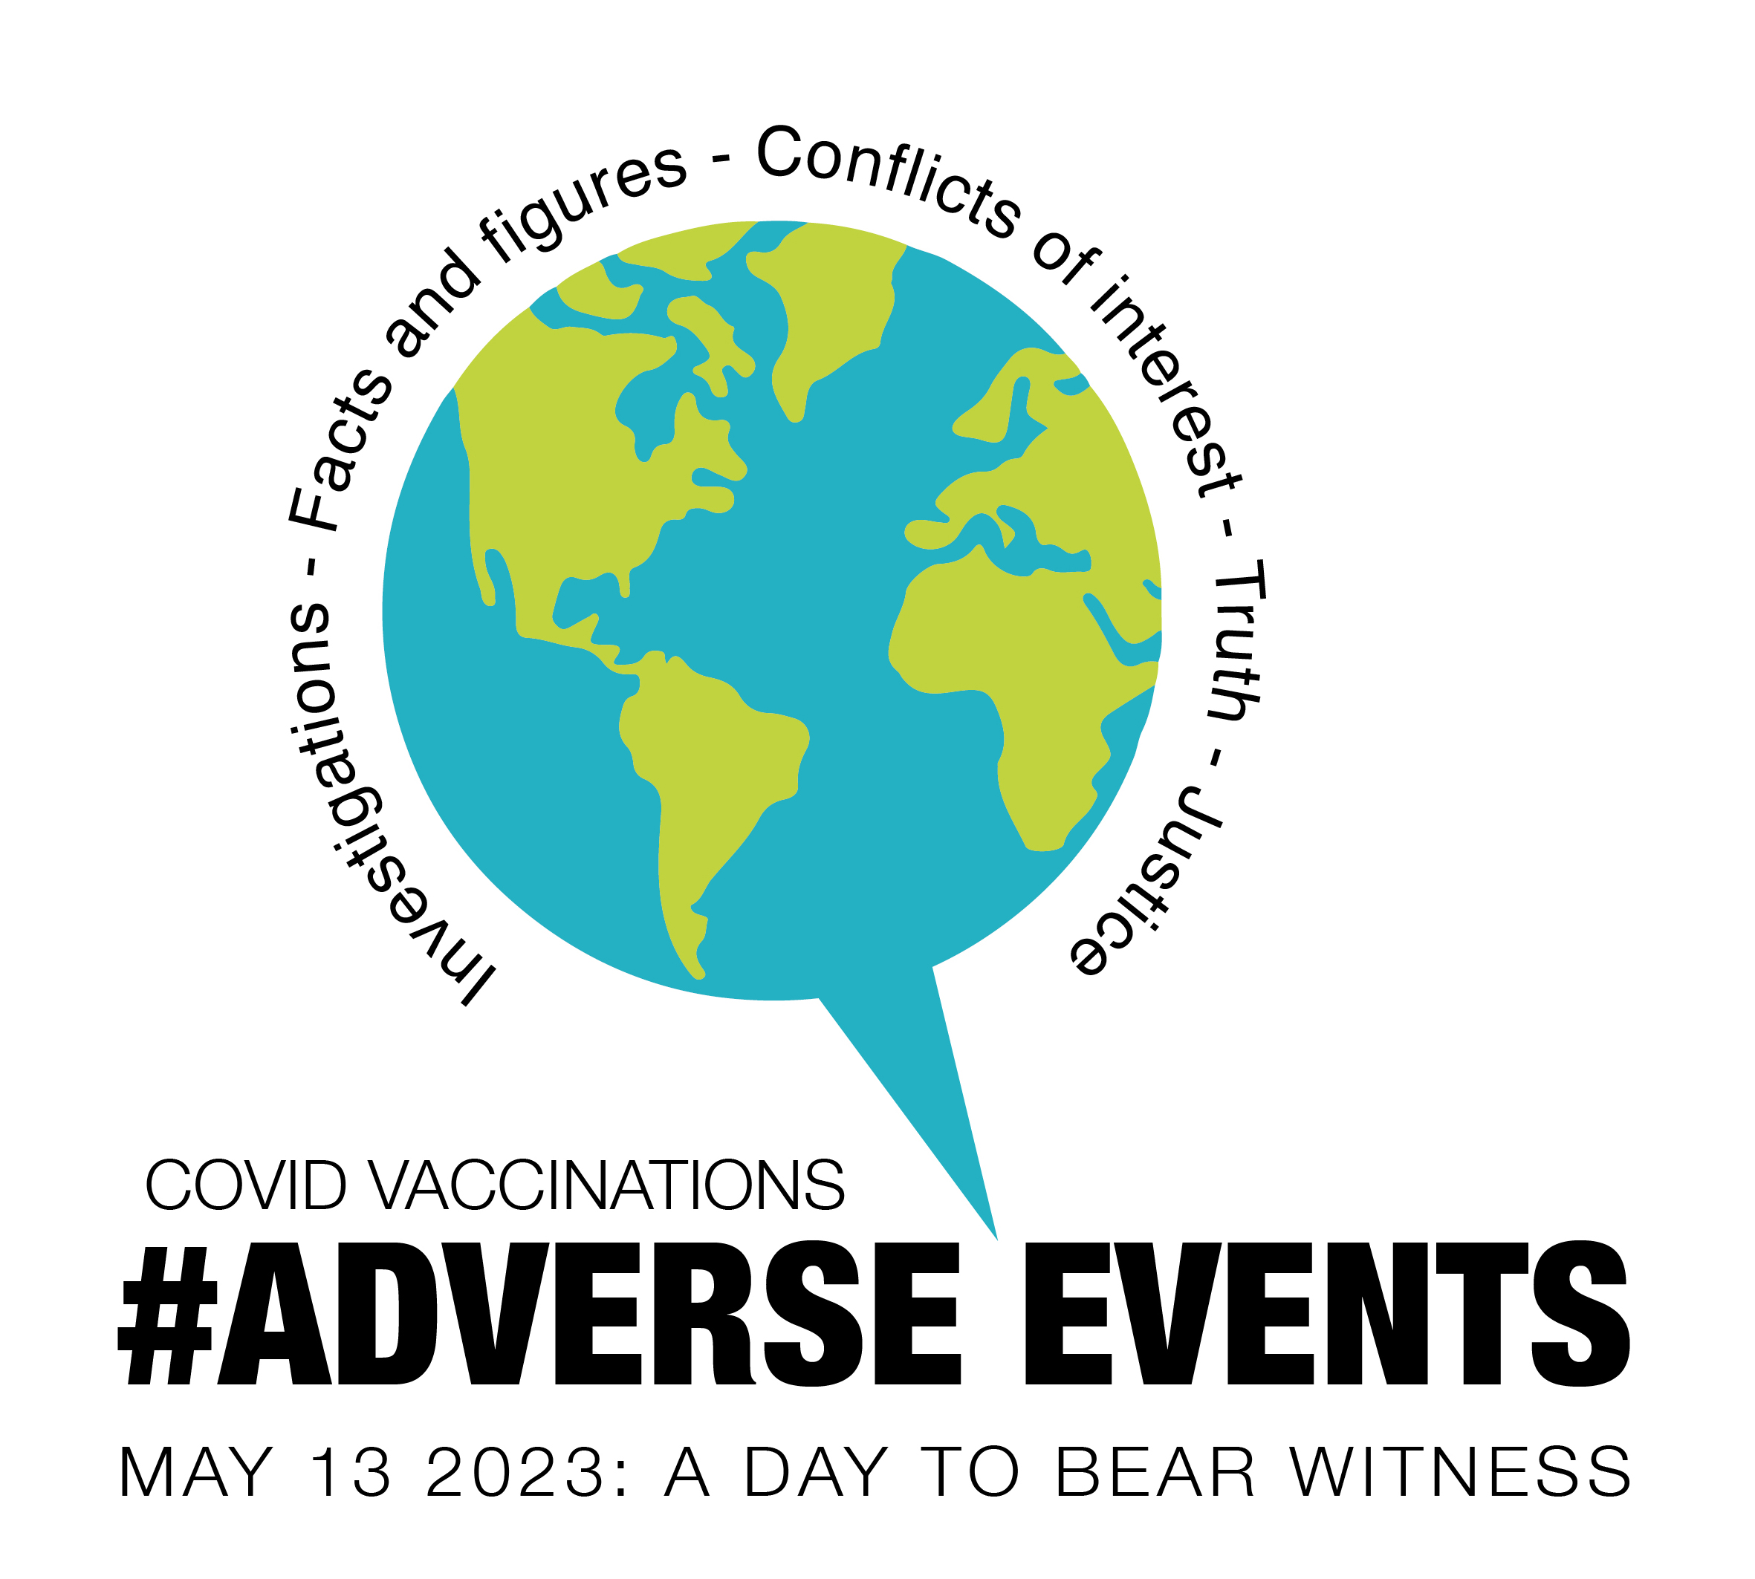

Telegram channel for information :
13 May - World - Together for Truth

#ADVERSE EVENTS

European Forum For Vaccine Vigilance - Isofia International Children Health Defense Europe - Ligue Nationale Pour la Liberté des Vaccinations - GreLiVe Grenoble – Action 200 Perpignan - Collectifs du 77 - Alliance du Peuple-ADP TV - Verity France - Association Internationale Pour une Médecine Scientifique et Bienveillante- Réseau des Victimes des Accidents Vaccinaux - Dépêches Citoyennes - Aletheia Italia ...

invite you to participate in a joint day of action on 13 May 2023:

COVID vaccinations

May 13 2023 - A Day to Bear Witness
Hello to all of you,

We propose to participate in a first large-scale joint action in as many European and World cities as possible on Saturday 13 May 2023.
The success of the formula in France on December 10 (79 meetings in 53 places, with a significant media coverage) and elsewhere in other occasions, in other coutries, gives us reason to believe that this international event could make a difference.
Their war is international, through institutions, lobbies and media, ad as such we need international resistance. We cannot remain separated, because of an illusory feeling of helplessness, of disorganisation or even because of a personal ambitiion or distrust, loosing opportunities, inspiration, strength and efficiency to work at a global scale. We are dozens of millions, hundreds of millions, billions to refuse their dystopic future. Let’s prove that we are numerous, informed and organised everywhere.
Let 2023 be the year of our European Unity and why not World unity.

The Concept : Witness through portraits, words and figures
In partnership with the structures and personalities mentioned at the beginning of this document (and all the others that will join us) , and families of the victims, the 10 December collectives – Pour Changer l’Histoir are calling for a public European Day of witnessing on the covid 19 vaccines adverse events all around Europe.
The unifying elements will be large portraits of people (A1 if possible) who died from injections, or who were seriously affected by them, direct witnessings by the victims themselves, by their relatives or organisations, and facts and figures.
The cost of the large portraits should not be a deterrent: even well-mounted A2 or A3 colour posters are effective.
The action will be carried out in the most pacifist, but also the most dignified and strongest possible way, to communicate about the serious and deadly adverse events of Covid vaccines.
Each portrait will be accompanied by a few very clear lines, visible from a distance, specifying, without detailing the nationality: the first and last name of the person, the age, the injection given, the time and cause of death, or the serious undesirable adverse events caused. And sometimes a ban on autopsies.
Last year, Verity France launched the Call of the 18 June in Paris, on the anniversary day of a famous speech by the Général de Gaulle calling to resistance in 1940. On the 10 december, the Day of the Human Rights, we launched A Day to Bear Witness and to Change History in the whole France. This year, we choosed the 13 may close to Europe Day (9 May) without thinking of this famous speech by Winston Churchill, but it is certainly not a chance :
« We are in the preliminary stage of one of the greatest battles in history.... You ask, what is our policy? I will say: It is to wage war (...) with all our might and with all the strength that God can give us; to wage war against a monstrous tyranny, never surpassed in the dark and lamentable catalogue of human crime. That is our policy. You ask, what is our aim? I can answer in one word: Victory. » Blood, toil, tears and sweat
And let’s add this other words by the same :
« We shall fight on the beaches, we shall fight on the landing grounds, we shall fight in the fields and in the streets, we shall fight in the hills; we shall never surrender. »
On 13 May 2023, let’s fight everywhere in Europe exposing the truth and making it a founding day for the Resistance.
A total war against the living has started through these injections that can allow still sleeping people to open their eyes on the big picture : what has started being done to the Human is what has been done to the Earth for years : sterilisation of the soils, GMOs, and now for us : artificial Intelligence, disappearance of cash, destruction of the hospital, prohibition of care, tracking, digital identity, abolition of the human/machine border, manipulation of embryonic stem cells, hyperviolence of screens, transgender propaganda... RNA covid vaccines affecting the genetic program of billions of men, women and children, perhaps soon to be integrated into all vaccinations… All this while impoverishing the populations.
From 10am or 2pm depending on our possibilities, let's bear witness everywhere of the adverse events of Covid vaccinations, by word and image, let's encourage and bring our loved ones and anyone we know to bear witness! The uselessness and damage caused by injections have started to spread in people's consciousness, and a fundamental work is underway.
If every one of our voices didn't count, they wouldn't try to control any of them.
Every voice that carries the truth makes them tremble and shake.
Inform people around you, including national and international resistance leaders.
There are so many of us who refuse to accept this world and the story that is being told . Everything depends on our silence and our disunity.
Let us show where passivity or submission can only lead, while organising ourselves is possible, locally and everywhere, in non-violence and non-cooperation with the oppressor, in order to build together the true and free future of the peoples.
History has shown us many times that, through the testimony and perseverance of victims, lawyers, associations, whistleblowers, journalists, politicians... scandals break, injustices are stopped, corrupt governments fall.

Let us meet on 13 May!

"Give me a fulcrum and I will lift the world" Archimedes

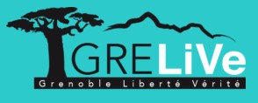
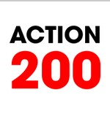
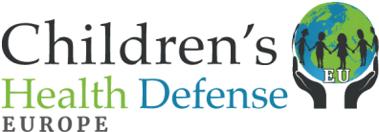

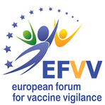
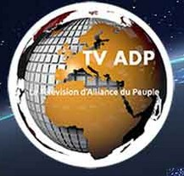

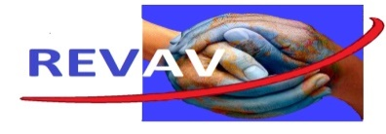

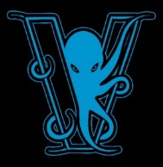

The formula
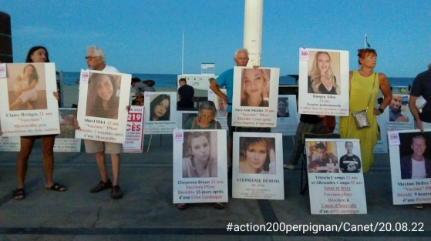  Le Canet, France August 2022 | 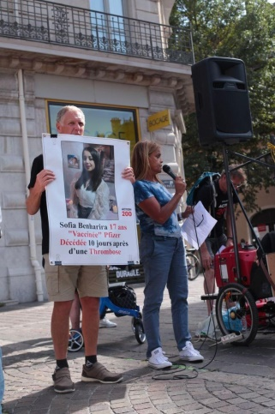  Grenoble, France September 2022 | 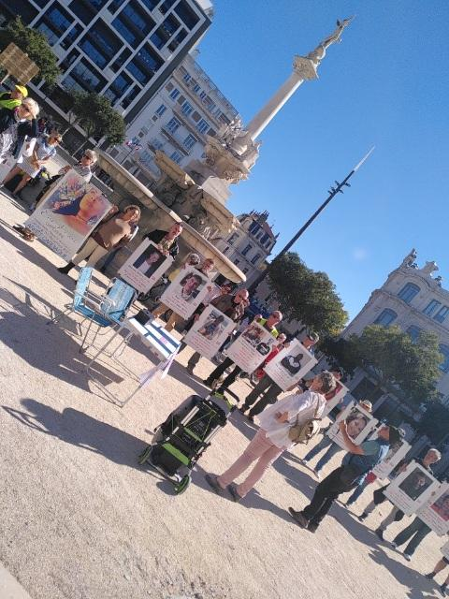  Valence, France October 2022
Video Le Canet August 2022
https://crowdbunker.com/v/XCES2G9nK8
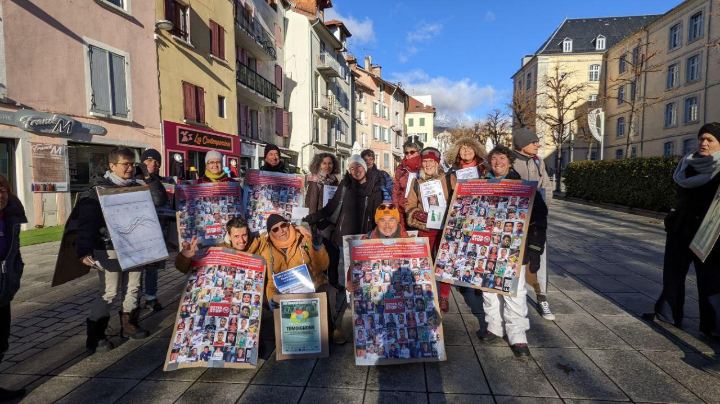
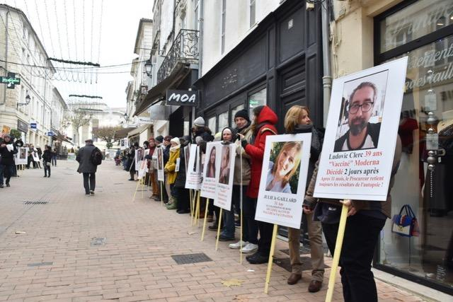

Privas, France, 10 december 2022 Saintes, France, 10 dec. 2022

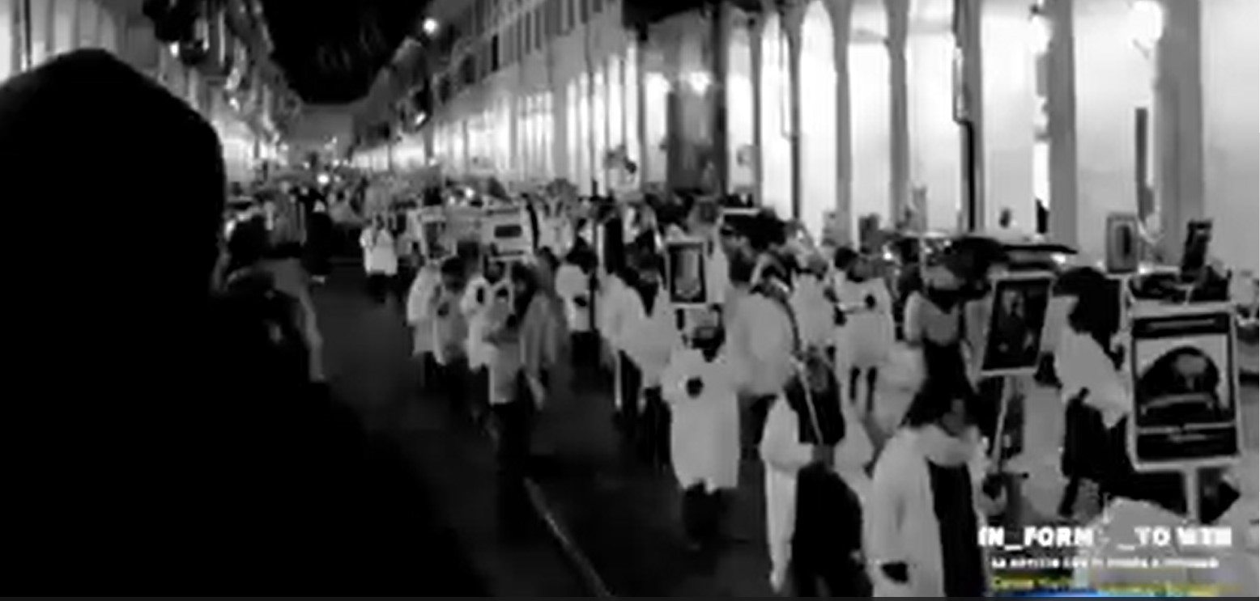

Torino, january 2023

Why this formula?
Waking up the still sleeping minds is the only safe and in any case necessary solution to stop the tyranny that has been announced, and the sooner we wake them up, the sooner the nightmare that has already begun will end.
When you try to wake people up, as you probably know from your own experience, it is difficult to fight against the sometimes almost religious programming.
And yet the formula of presenting large portraits of the victims, which we have tested extensively, works to open eyes and dialogue and to sway the convictions of the most persuaded.
With this formula, Action 200 Perpignan, for more than 10 months, has reached tens of thousands of people directly and totalled more than 50 million internet views through the sharing of photos and videos in several countries of the world. Other collectives have been able to verify this.
Beyond these figures, the formula has also shaken many convictions, and not always the least.
The presentation of undeniable facts with faces allows for that first, difficult, necessary and effective break in the conditioning. These visual and silent testimonies, devoid of aggression or claims, touch heads, bodies and hearts directly. They bring people face to face with a reality that affects them and, as you know, once the lies are challenged, there is no going back to sleep. Finally, speaking out for the victims in a peaceful way helps to bypass any labelling.
In our collectives, all those who have experienced these actions have seen them as a strong and beautiful tool that makes a difference, in the realm of catharsis, a renewal of hope to reach the population... and they have seen the validity of this hope in the reaction of passers-by.

So... let's apply this formula on a large scale.

The sphere of reinformation today has a capacity to reach a wider population than the traditional media, which is too often subservient to interests contrary to those of humanity, and a capacity to influence better provided that it avoids being pigeonholed and uses the right message. Also, arming all reinformers with this message through a large-scale event will increase the impact exponentially.
It is also a unique opportunity to work together, to learn to coordinate rather than to remain fragmented, while there are tens of thousands of us engaged on the ground, millions convinced but silent, and tens of millions waiting for facts and figures to change their minds and join us.

Let us make 13 May everywhere a national and international day of witness and truth that no one will be able to refuse to see, in a way that we hope none of us will have reason to refuse.

Every support counts
Several associations, active groups and personalities have already given their support to the event to prepare and launch this action, which already ensures a mobilisation and a scope that we hope will be worth the effort for you to participate with us on 13 May.
You probably already know them, but the aim of the event is for the whole of France and even Europe to come together with collectives, associations, individuals, witnesses and "influencers".
Together we will succeed.

Contacts and information still in progress,

ISOFIA Intenternational https://www.isofiaensemble.net/
Amrita Tejas amritatejas7@gmail.com

Grelive
https://www.grelive.fr
François-Marie Périer, fmperier@yahoo.fr
06 46 68 48 79
Ligue Nationale Pour la Liberté des Vaccinations
https:infofaccin.co.uk/contact
contact@infovaccin.fr
+33 4 50 10 12 09
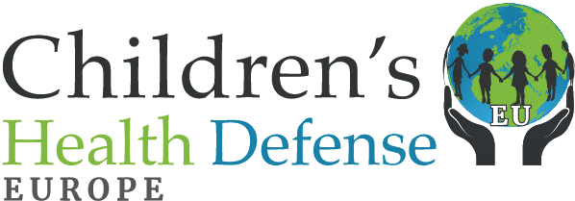 | Children's Health Defense  https://childrenshealthdefense.eu  lisa@chdeurope.org
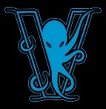 | Verity France  https://www.verity-france.org
Association Internationale Pour une Médecine Scientifique et Bienveillante
https://www.aimsb.org
Collectifs du 77
Anne: vibratoire@protonmail.com
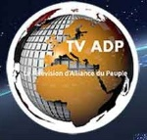 | Alliance du Peuple - ADP TV  https://www.tvadp.fr  Pamela: alliancedupeuple@gmail.com
Revav
https://www.revahb.fr
guillaume.ageorges@free.fr , asso.revav@orange.fr

Charter
We ask that you respect the event's charter. It is understood that we are human, that we cannot foresee everything, but our words and actions must contribute to the general interest and to the success of the event.

It is a gathering where partisan, religious or ideological speeches are not appropriate, where we will consciously avoid ostensibly pulling the wool over one's eyes: we must be united and converge today like the Resistance fighters did yesterday, whatever our political affiliation or lack of it, because we are in a common fight for humanity and for our children, beyond all the natural and artificial divisions between us.
The only legitimate political elements in such action are public health, public interest, justice and freedom, including freedom of information. And the message is more important than the messenger.

We will attract more useful interest in our specific causes by refusing to go into detail on that day, and by postponing such discussions. We are there to draw attention to the danger for our interlocutors and society, to create a breach in the misinformation we are victims of, to reassure that nobody is alone, that there are support structures, and to decide the public that it is urgent to mobilise, if only by refusing unnecessary and dangerous measures from now on. In the end, we will get more attention and have more effect.
The watchword is dignity in all our actions and words, clarity and irreproachability in our testimonies, facts and figures, revealing the content of this crisis and the direction it would have us take.

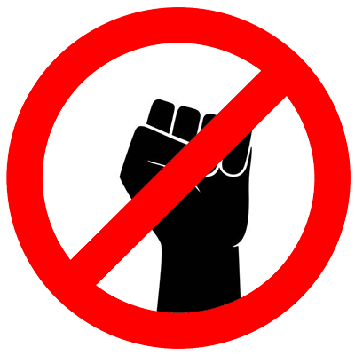 | Violence absolutely forbidden and refused.  Whatever your pain, indignation and anger, violence will prevent the message from getting through. The slightest trace of resentment or spite in your words can undermine your credibility and ours with people who are not usually responsible for the situation, or others who despise people who are overwhelmed by their emotions.  Letting off steam serves no purpose and only fuels what we are fighting.  Avoid recriminations, verbal traps and provocations, don't get the portraits confiscated, stay legal and efficient.  Do not stay alone. Resist provocation, avoid confrontation. Ask questions, quote figures and official reports humbly but firmly, point out contradictory statements and admissions by politicians and doctors: this will eventually disarm even the worst provocateurs in front of the audience.
Avoid bringing up any controversial topics at the event that could label you.
Do not accept labels that may be given to you to discredit you. Say no, explicitly. Question the reasoning, or at worst call for the label or prejudice to be investigated. Not giving an answer by referring to the facts is sometimes the most effective. For example:
"This is not the day for that. We are here for the victims, and to prevent you from becoming one of them one day soon."
"Take up the definition of fascism, which is the oppression of the weakest and the right of the strongest by hierarchical and authoritarian structures at the service opf a state or an empire, using censorship and intimidation. And tell us how we fit in or not, whereas we are the only ones to warn about the damage suffered by defenceless children and elders more than everybody. Are we obscurantist and dangerous when we are the only ones to quote official figures on the adverse events of useless and catastrophic vaccinations promoted by the most corrupt firms and to put forward the precautionary principle? Do I look like a member of a government that, in collusion with corporations, tramples on freedoms and the public interest?"
"In the light of history and experience, irrationality, lack of culture and irresponsibility are on the side of the accusers."
Whatever our doubts and certainties, let's avoid all the difficult, slippery topics, labelled as far-fetched, but also the hypotheses not commonly accepted beyond what we bring the proof of that day, audible by all. Be careful, because even a UFO fan in the audience, for example, can take the discussion beyond what the rest of the audience is ready to hear, and cause problems.
Let's focus on the indisputable facts and the questions they raise.
"Whatever the truth is, this is not the time to talk about it. A clear understanding of the issue of Covid or other vaccines will, no doubt, lead to many other understandings. It is very counterproductive to want to agree on everything and to want to hear everything at the same time."

Organisation and Preparation

Present the project to your teams. Announce the event
By whatever means you can, mobilise the collectives, Signal and Telegram groups, YouTube, Rumble channels etc. and those who listen to you. Encourage them to participate, even briefly, even if it is to ask questions. Regularly remind them of the name of the event, its date and its message.

Awareness raising and call for testimonies
Once you have decided to participate in this day, get people to testify, show them that testimonies of individuals have changed the history of medicine and patients. Point out the pride and good that comes out of the testimonies, for them, their loved ones, the future, the memory of their fathers, mothers and ancestors, and the protection provided by a lawyer eventually. Doctors and all personalities of the resistance should really call to testify for themselves or their relatives and join us as many as possible.

Spam and acknowledgement of receipt
We have seen a sharp increase in false spam labels between organisations' collectives and mailing lists. Please ensure that you receive the emails correctly.

Preparing interventions
Along with the portraits of the deceased or victims of injections, the pillars of this day should be the victims of Covid vaccinations, but also possibly the victims of other vaccinations if they wish to take advantage of this opportunity to testify, always making the link with the current situation and without blurring the present message.
Experts or personalities can also be effective speakers.
Contact them directly if you know them, or local representatives of national or international associations, remembering that you are participating in an event that brings together recognised structures and other associations alerting to the dangers of vaccinations, such as REVAV, LNPLV, Verity France, CHD or the collectives that launched the project, who can put you in touch with parents and families of these victims, who have come to speak at various rallies, and to whom we express our gratitude today for their courage and dedication.

In each locality, as far as possible, at least one victim and one personality could be present, for the attractiveness of the event, but also for the participants and the media, but without this ever taking precedence over the visual and direct message of the victims' portraits, which is always the foundation of this day.

We will also try to benefit from the testimonies of the various professions affected and/or suspended and the age groups impacted by compulsory vaccinations: nurses, firemen, all medical and social personnel, police officers, teachers, children, high school students, adults and the elderly. They too are victims.

Let's have the many personalities of our resistance spread over many places, even silently or very quietly if they wish to let the testimony of the portraits speak for themselves, but still attracting participants, media and internet views.
Depending on the preparations and spontaneous arrivals, we will be joined by witnesses, NGO representatives, victims' associations, whistleblowers, scientists, journalists, doctors and carers, politicians and media personalities... to create links, raise awareness and show that we are there for the future of all. We are acting united for humanity.

Let’s see what technical means we can mobilise for these interventions (sound system for example).

Prepare portraits and displays
Unfortunately, not all victims can speak, and the portraits of those who can no longer speak are a key element of the event, to open up dialogue and awareness.
Each team organising the event will have had a number of A1 portraits printed or made. But individuals may also freely print portraits, trying to avoid duplication.
As mentioned in the introduction, the cost of A1 signs should not be a deterrent, everyone should be able to join the action, and there are several solutions:
1) we can make a call for a fund to help the destitute collectives;
2) You can print on A2 or A3 colour like the funeral marches in Italy.
No bans, everyone is welcome, we should not cut ourselves off from anyone and diversity will even be a plus in order not to be labelled as a pyramidal organisation that is more easily attacked.
To have each portrait printed costs between 15 and 20 euros in total for a print on a waterproof, wind and tear resistant canvas sheet, washable mount with glue or strong clips allowing it to be reused often and to be lent out.
The collectives can provide you with addresses of companies we have already worked with, but getting local printers to work is good too.
For those who wish to do so, models of visuals, general or adaptable to the places and times of the gatherings, can be proposed.

Action 200 Perpignan provides PDFs of its clear, strong, visible and legible montages that have proven to be effective. Verity France also has a number of them on its website. And there is nothing to prevent the creation of your own images in accordance with the charter.

For image rights reasons, Verity France's resources can be used first. In the weeks leading up to the event, let's make sure that new testimonies emerge, with other portraits that will awaken other consciences. So far there have been no problems with foreign portraits for which rights have not been expressly requested, but it will be a personal choice of the people who print.

Making a « Me Too » for vaccines, keep in mind the objective of a first breach to lift the veil on a whole system
The challenge is for this vaccine scandal and the unveiling of the regime that imposes it to move people's consciences and make them understand the rest, as one person can bring down an entire network and system, just as Me Too did for sexual harassment in Hollywood. The victims of the other vaccines, in particular the compulsory ones, help to remind us of the liberticide side still in place, the danger still run (including the evocation of the return of the mask and the integration of the covid RNA vaccines into the seasonal flu vaccines) in order to become aware of the mafia aspect that this industry has had for a long time.

Fighting a Mafia through witnesses, repentants, famous people, lawyers

We are faced with what is in practice a mafia, which, like all mafias, collaborates with the powers that be, and a mafia can be fought through the words of the victims and the repentant, famous people and lawyers, which leads to the obligation of the press to speak about it and the authorities to act. Important changes have occurred in this way in the past.

The other proven damages of sanitary measures
We must not forget the other proven damages of sanitary measures that have always caused the opposite of what they announced: confinements, tests, masks, passes, vaccinations have always harmed the health and freedom of the population without ever protecting the people at risk, for the exclusive benefit of pharmaceutical companies closely linked to governments, in scenarios that have already been repeated in history.
But let us respect the dignity and the fundamental message of the event.

Have planned argumentation and information with the official reports on adverse events.
It goes without saying that it is best to prepare speeches, facts, figures and documents, arguments and counter-arguments.
And, in accordance with the charter, to know the words to avoid while reconciling freedom and responsibility towards all and those who suffer the dramatic consequences of health measures, starting with vaccinations.

We recommend having with you, quoting and repeating the number of victims contained in the official figures: the ANSM's "Suivi des effets indésirables des vaccins Covid-19" (Monitoring of adverse effects of Covid-19 vaccines), the "Enquête (idem) de pharmacovigilance du vaccin Pfizer BioNTech Comirnaty des Hôpitaux de Strasbourg, Marseille, Toulouse et Bordeaux" (Pharmacovigilance survey of the Pfizer BioNTech Comirnaty vaccine of the Hospitals of Strasbourg, Marseille, Toulouse and Bordeaux), using the most recent versions downloadable from the ANSM website. Just enter the titles we have just mentioned on a search engine. But they will be part of the kit provided to participants.

Vaccination is mathematically much more dangerous than Covid

Let us calmly repeat to the interlocutors that any statistician, using the official reports and the risk of serious Covid for the population (0.05%) and even more for young people (0.02%), knows that vaccination is mathematically much more dangerous than Covid, and that real-life or clinical experience confirms this more and more each day as the effects appear. Tell that every three weeks, more than 500 people's lives have been or will officially be shattered by the adverse events of unnecessary and imposed vaccines. These figures should actually be multiplied several times over, according to all those who have studied them seriously.

Let's recall by a sentence that in France for instance a vaccine doctor was paid 450 euros for half a day in a vaccinodrome whereas each declaration of adverse event reported by a victim requires an hour for a doctor who must take his free time and is not paid.

Preparing teams to discuss
As I have often ended up in discussions where this was useful, it would be preferable for each team to have several printed elements with them, in particular indisputable sources (official and clear documents).
Some lines are more easily opened up or accepted.

Everyone should, as mentioned above, have its own country’s latest pharmacovigilance reports, as well as those of the European Medicine Agency-Eudra Vigilance, or USA VAERS (Vaccine Adverse Event Report System) to be able to read and easily show the latest statistics, damage and inefficiency of health programmes.
Detoxification tips, ways to report adverse events, and complaints can be cautiously suggested by referring to online addresses and resources.

Having a brief chronology of the crisis to give back memory

Ideally, a relentless chronology of this crisis will be prepared, not too short, not too long, with dates, facts, promises, contradictions, confessions, corruption, human rights violations, to clearly show the deception, to give back the memory to the people who have been constantly guilted and drowned in information and paradoxical injunctions, and to unite us and touch the heart of the people, because we all know the direction they want us to take. It is always possible to bring someone or a group of people to see the truth. The choice that will follow is theirs, but at least we will have, by the appropriate means, shown the reality without denial being possible. Particular emphasis will be placed on children and the elderly.

Violations of the Human Rights declarations

All the fundamental declarations related to human rights have been violated in the last two and a half years: Hippocratic Oath for doctors, obliging them to treat and not to obey orders or financial interests; Munich Charter for journalists where they commit themselves to seek and tell the truth for the benefit of populations and human rights; Nuremberg Protocol and Oviedo Convention for Justice which did not enforce the prohibition of pressure and experimentation of medicine on humans without accurate and impartial information which was never provided, but censored.

Explaining the process of adverse events : Dengvaxia, antibodies, spike protein, HLA system

We can explain the process of interfering vaccinations, during the epidemic, on people who already have antibodies, inevitably leading to "overdoses", blood clots and accidents, as with the Dengvaxia of Sanofi-Aventis in the Philippines, the auto-reproduction of spike protein the destruction of the immune system As well as the the fatal reactions due to our different immune systems (HLA-Human Leukocyte Antigen) revealed by the Nobel Prize in Medicine Jean Dausset in 1980.

Other historic informations and argumentation tools
« Diet, injections, and injunctions will combine, from a very early age, to produce the sort of character and the sort of beliefs that the authorities consider desirable, and any serious criticism of the powers that be will become psychologically impossible. Even if all are miserable, all will believe themselves happy, because the government will tell them that they are so. » Bertrand Russell, Nobel Prize, The Impact of Science on Society, Blackie and Son, 1944, chap. 3

Other useful tools will be at your disposal, some of which already exist and others which are being prepared with the partner structures.
Organisations, personalities, websites and groups that we know well have decisive and effective historical or current facts and figures at our disposal, if we know how to handle them with the necessary tact, without asserting them in an aggressive manner.
Use what works best, the elements you feel in tune with and the experience of other collectives.

Location and Distribution of Rallies
The meeting points and times with practical details will be communicated by the collectives and associations as and when they become available on the Signal and/or Telegram groups, websites, web medias etc.
It is best to choose the busiest places in towns and villages, avoiding places that are too crowded or where people are in a hurry. Markets and shopping streets in particular are excellent places, preferable to shopping centres.
It is also possible that small groups are spread out in the cities in different places, always with a distance allowing legibility and repetition effect so that the passers-by really have the impression to see witnesses everywhere, just like the victims of these vaccinations everywhere around them. It may be cautious if the participants do not lose sight of each other for safety reasons.

Legal obligations
Information and legal texts can be provided on how to report the event to the local administrations or cities.

Communication and Animation
Let's go beyond portraits, discussions and animations on the day.

Witnessing differently : cars, balconies, windows...
Why not bear witness through our cars, on our balconies or windows through portraits, figures, sentences pronounced by politicians and denied by the facts?

Music
Musical or artistic interventions that open up hearts can really make a difference to the event, whether artists are well-known or not.

Media and Broadcasting
Think about encouraging, or even organising as much as possible, a live broadcast by alternative media, by the participants and by the public, as well as the impact of the event afterwards.

TV ADP (Alliance du Peuple), which aims to help all French collectives, is a partner of the event and intends to extend it internationally. But many media, youtubers or independent people will be able to relay the event as widely as possible.
Dépêches Citoyennes has also joined us.
This will be an opportunity to collaborate with the Citizen Light initiative, which we strongly encourage.
Interventions in English and other languages can be made to relay and send messages of unity to other countries.
Ideally, live Facebook and YouTube broadcasts, for example, live sharing, photo and video capture, should be organised, especially if there are strong moments or powerful interventions.
On that day, the Europe of the Peoples will join and will reaffirm its historic tradition of freedom, solidarity, real Humanistic civilisation.

Mainstream press
Despite the often painful experience of the past, it is best never to neglect contacting the press, which is also evolving, and it can be decisive to invite it, as it often brings repercussions beyond our expectations. For example, in Grenoble, in september 2022, a single journalist from Place Grenet at a gathering of families of victims of vaccinations brought an honest report and almost 40,000 views and 2,400 shares. In Brest, Brittany, in october 2022, a decent article in the Telegramme, with a print run of 180,000 copies plus the Internet version, led to shares throughout France and the French-speaking world the very next day, leading to the decision to organise the December 10 event. On this day, we can estimate that through local newspapers, radios and TV, more than 1 million people were touched by the mainstream medias, which means largely non informed people all over France.

Policies
Similarly, let's not neglect to courteously invite politicians, with a brief reminder of the facts through the reports on adverse events, and a press kit: we often ignore the scope and action of the emails sent despite the silence of the interlocutors, and the underground work done by some to save lives and change opinion and the future. We know that changing the discourse is also part of politics and policies.
Witnesses, families, groups, associations, media, individuals, children, young people, parents, elders, families, of all origins, each and every one of you, each of your presence and each of your testimonies counts beyond what you can imagine!

LET'S MEET ON 13 May!

François-Marie Périer, coordinator of Pour Changer l’Histoire, Ligue Nationale pour la Liberté des Vaccinations.
fmperier@yahoo.fr, 00 33 6 46 68 48 79

Organisators can ask to be added on the Telegram group

Amrita Tejas, Isofia International, amritatejas7@gmail.com
To join this action, contact us, either at the coordinates above, or on the Telegram channel

Some films about real facts or about our reality
to give faith

The Firm, Sidney Pollack, 1993
The Idealist, Francis Ford Coppola, 1997
Revelations, Michael Mann, 1999
Erin Brockovich, Steven Soderbergh, 2000
The Constant Gardener, Fernando Meirelles, 2005
V for Vendetta, James McTeigue, 2005
Michael Clayton, Tony Gilroy, 2007
The Shock Doctrine, Naomie Klein, 2009
Promised Land, Gus van Sant, 2012
Cloud Atlas, The Wachowski, 2012
La fille de Brest, Emmanuelle Bercot, 2016
Dark Waters, Todd Haynes, 2019
Crisis, Nicholas Jarecki, 2020
Goliath, Frédéric Tellier, 2022

